Clustering Similar Neighborhood in Different Cities

Md Nazrul Islam

May, 2020

1 Introduction

1.1 Background

Different cities in the world are filled with numerous kinds of venues that in turn define the cultures of the cities. A city not only differs from another by means of global positioning, what it to showcase to its inhabitants or tourists has put a significant mark on differentiating it from the rest. Despite of having dissimilarities, it is somewhat possible to group together the similar kind of neighborhoods in different cities. It is possible to segment the different venues in a neighborhood according to venue category, and then to group neighborhoods together that incorporate similar kind of neighborhoods. Having grouped together similar kind of neighborhoods may serve as a variable to help make a decision when people consider moving out of a city to another.

1.2 Problem

Finding identical neighborhoods in different cities in order to help provide a perception of similar neighborhoods which may provide with a great deal of insights in order to make a decision of choosing a neighborhood that is far away, yet somewhat feels like home.

2 Data Acquisition and Cleaning

2.1 Data Sources

This project works with two sets of data. The first dataset consists of New York’s different neighborhoods and their respective geometric coordinates. The second dataset consists of Toronto’s different borough and their respective postcodes.

2.2 Data Cleaning

The first data source is in json format. It initially consisted of many different classes of data. Upon examining them, the data that we are interested in was found under ‘features’

category. Further formatting of the json data finally resulted in a dataframe that consists of 4 columns, namely: Borough, Neighborhood, Latitude and Longitude.

The second data source is a Wikipedia page that contains Postcode of the city of Toronto in a wikitable. To scrape the data from the URL, BeautifulSoup has been used to extract the table data. After going through a few more steps, the dataframe was obtained which consists of: PostalCode, Borough and Neighborhood.

But the problem with this dataframe was, it has some values under the column ‘Borough’ which were not assigned in the first place. So, the rows with no assigned value in the ‘Borough’ column were dropped. Another problem was there were a few rows in the ‘Neighborhood’ column that too had no values assigned to it. As a solution, the value from the ‘Borough’ column of the respective row was copied into the ‘Neighborhood’ column.

2.3 Feature Selection

Now that we have obtained the different neighborhoods and their respective geometric coordinates for the city of New York and Toronto, it is time to come up with different venues that the different venues have to offer.

Foursquare API provides with an access to an enormous database consisting of venues from all around the world including rich variety of information such as addresses, tips, photos and comments. Having signed up for a Foursquare developer, using the Client ID and Client Secret, it is possible to make API requests in order in order to retrieve venue information.

By feeding a function with Neighborhood name and its geometric coordinates, using Foursquare API different venues (Restaurants, Coffee shops, etc) were extracted. After performing One-Hot-Encoding and grouping together the rows by neighborhoods, the NY dataset and Toronto dataset seemed to share 250 features. Both the dataframes were combined into a single dataframe in order to perform clustering operation.
2.4 Dimensionality Reduction

Principal Component Analysis is a dimension-reduction tool that can be used to reduce a large set of variables to a small set that still contains most of the information from the large set. Principal component analysis (PCA) is a mathematical procedure that transforms a number of (possibly) correlated variables into a (smaller) number of uncorrelated variables called principal components.

Before diving into clustering operation, first we performed dimensionality reduction using Principal Component Analysis on the dataframe in order to reduce the number of dimensions.
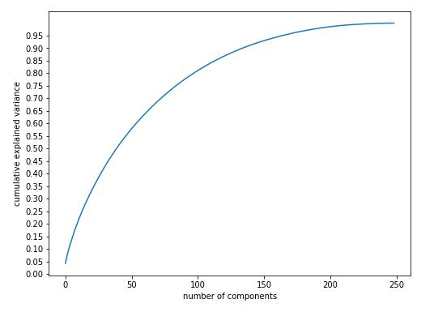

Figure 2.1 Selection of number of Principal Component

Having performed PCA, the number of features was reduced to 150 from 250 yet retaining the maximum variance of the dataset.

3 Methodology

The goal of this project is to group together the similar neighborhoods in the city of New York and Toronto. The cluster number is set to 5 after analyzing the data and the visualization of clusters were done accordingly.

4 Results

4.1 Visualizing the Clusters on the Map

We created folium maps to help obtain a visual perception of how the very different clusters look on the map when plotted on the map of the city of New York and Toronto.
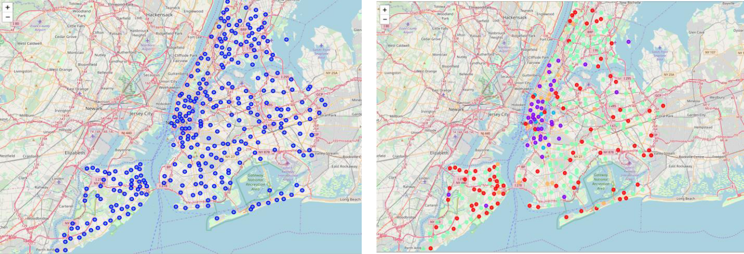

Figure 4.1 (a) Figure 4.1(b)

Figure 4.1 (a) Venues pinned on NY before Clustering (b) Venues pinned on NY after Clustering

The very different venues in the city of NY have been clustered into 5 distinctive clusters represented by different colors in the Figure 4.1 (b). Now, to comply with the initial goal of finding similar neighborhood in a different city is being visualized in the Figure 4.2 (a). The points of similar color in the Figure 4.1 (b) and again, in the Figure 4.2 (b) represent similar neighborhood in terms of venue information that we obtained from Foursquare API.
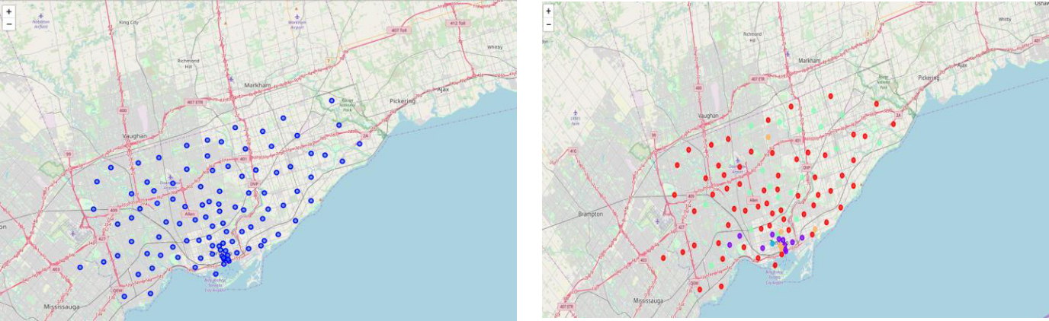

Figure 4.2 (a) Figure 4.2 (b)

Figure 4.2 (a) Venues pinned on Toronto before Clustering (b) Venues pinned on Toronto after Clustering

5 Discussion

Since this is an unsupervised clustering work, many different approaches can be adopted in order to achieve better results. The project was only done on the zip codes of New York and Toronto, each having 150 features, even after performing dimensionality reduction. Having more samples may result in a better clustering

Having dealt with location data on a deeper level, for instance at neighborhood level may result in better grouping of similar data points which eventually may result is better clustering. The study here is being ended by visualizing the data and clustering information on the map of the City of New York and Toronto.
6 Conclusion

People are frequently moving into new cities. And in this ever growing world filled with technology, having a neighborhood recommendation based on location data is something to be considered basic now-a-days. And the application of neighborhood segmentation lies beyond this application too. This can serve to be an impressive tool to better organize a city resources. Furthermore, it can be used as a tool for security measurement if combined with crime data.

